Regulation of Breathing Movements
Our body undergoes so many changes and we need to be able to have ongoing oxygen and get rid of carbon dioxide waste from cellular respiration
How do we manage this?

Chemoreceptors and the Brain
Chemoreceptor:
The medulla oblongata
Two types of chemoreceptors:
1.
2.
- carbon dioxide/acid chemoreceptor is because our body is VERY sensitive to too much CO₂ build up
- toxic= deadly= not good
If high levels of CO₂ are detected:
- initiates increased
- Result=
Carotid and Aortic bodies- specialized type of chemoreceptor
- Carotid and Aortic bodies are found in the carotid and aortic arteries.
- Main function:
When they detect low levels of O₂:
- they send a nerve impulse (message)
- initiates increased
- Result= increase breathing

Exercise Response #1
- During exercise,
- Therefore CO₂ levels increase
- This stimulates in the medulla oblongata of our brain
- initiates increased rib muscles and diaphragm movements
- Result= increase breathing
- That’s why you breathe heavy when you are working hard= because your body needs more oxygen and is making more CO₂
Exercise Response #2
- Your adrenal gland stimulates the release of
- This causes breathing rate to increase
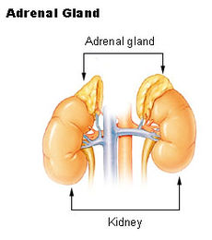

Do: 9.1-9.3 Study Sheet – quiz tomorrow

You can start: Respiration Disorder Assignment

