Regulation of Breathing Movements
Our body undergoes so many changes and we need to be able to have ongoing oxygen and get rid of carbon dioxide waste from cellular respiration
How do we manage this?
- Chemoreceptors
- Carotid and Aortic bodies

Chemoreceptors and the Brain
Chemoreceptor: specialized nerve receptor that is sensitive to specific chemicals
The medulla oblongata is the brainstem and it controls our automatic breathing movements
Two types of chemoreceptors:
1. oxygen chemoreceptor: monitors oxygen levels
2. carbon dioxide/acid chemoreceptor: monitors CO₂ levels and carbonic acid levels
- carbon dioxide/acid chemoreceptor is more important because our body is VERY sensitive to too much CO₂ build up
- toxic= deadly= not good
If high levels of CO₂ are detected:
- initiates increased rib muscles and diaphragm movements
- Result= increased breathing rate
Remember what these muscles look like (just know in general):
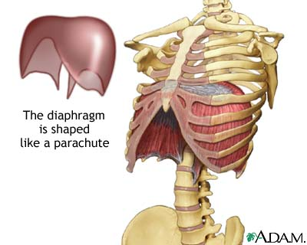

Carotid and Aortic bodies
- Carotid and Aortic bodies are found in the carotid and aortic arteries.
- Main function: detect low levels of O₂
When they detect low levels of O₂:
- they send a nerve impulse (message) to the medulla oblongata in the brain
- initiates increased rib muscles and diaphragm movements
- Result= increase breathing

Exercise Response #1
- During exercise, cellular respiration increases
- Therefore CO₂ levels increase
- This stimulates chemoreceptors in the medulla oblongata of our brain
- initiates increased rib muscles and diaphragm movements
- Result= increase breathing
- That’s why you breathe heavy when you are working hard= because your body needs more oxygen and is making more CO₂
Exercise Response #2
- Your adrenal gland stimulates the release of epinephrine (adrenaline)
- This causes breathing rate to increase
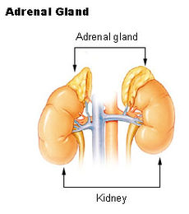

Do: 9.1-9.3 Study Sheet and Respiration Disorder Assignment

