The (KMT) says that all molecules/particles are in motion (kinetic means motion)

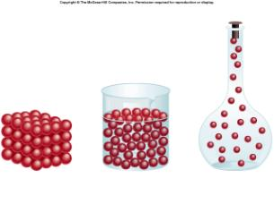

Solids Liquids Gases

Kinetic Molecular Theory- application to gases

- Pressure: the force exerted by the on the sides of
a
- Energy: thermal energy can be released or gained by molecules.
- When molecules gain thermal energy it is a gain in energy and therefore faster.
- Density is how molecules are and how much space is between molecules. This affects the substances
**These main ideas can be used to explain many technologies and observations of gases- let’s discuss some**

- Compressed Propane gas
- At room temperature the molecule of propane (C₃H₈) is a gas; in the gas the molecules are far apart from each other
- When you put the gas into a smaller container it is forcing the molecules to be closer together
- Hot Air Balloons
  - When the air in a balloon is heated the particles have gained kinetic energy
  - The particles are moving faster
  - When the particles hit the sides of the container they hit it with a greater force since they are moving faster
  - When many particles hit the wall of the balloon very fast there is an increase in pressure on the balloon
  - The balloon walls are EXPANDABLE though and will move to increase the volume (which decreases the high pressures)

Demo: Can we crush a Pop Can with Air???

Prediction

Observation

Explanation

An ideal (hypothetical) gas is defined by the following characteristics:

- The gas molecules are where they
until they with a particle or wall of container

- The gas molecules are ;they have but no
- The only interaction between molecules of the gas and container are collisions where is

Note: do not have these perfect characteristics however their behavior is not that far off of ideal gases but we make these assumptions to make experiments and calculations simplified

Can you try and explain an observation? Try explaining at least one of the following OR… pick your own observation about gases to explain.

- Why do geysers shoot water up into the air which such great force? (see picture on pg. 162)
- How come our chest cavity gets ‘smaller’ when we exhale? (see picture on pg. 157)

