HOW IN THE WORLD… Is there Transport in Plants??
Several factors contribute to the plant being able to transport materials.

- At the Roots
- osmosis
- root pressure
- In the stem
- cohesion/adhesion
- At the stomata in the leaves
- turgor pressure at stomata
- transpiration pull at stomata
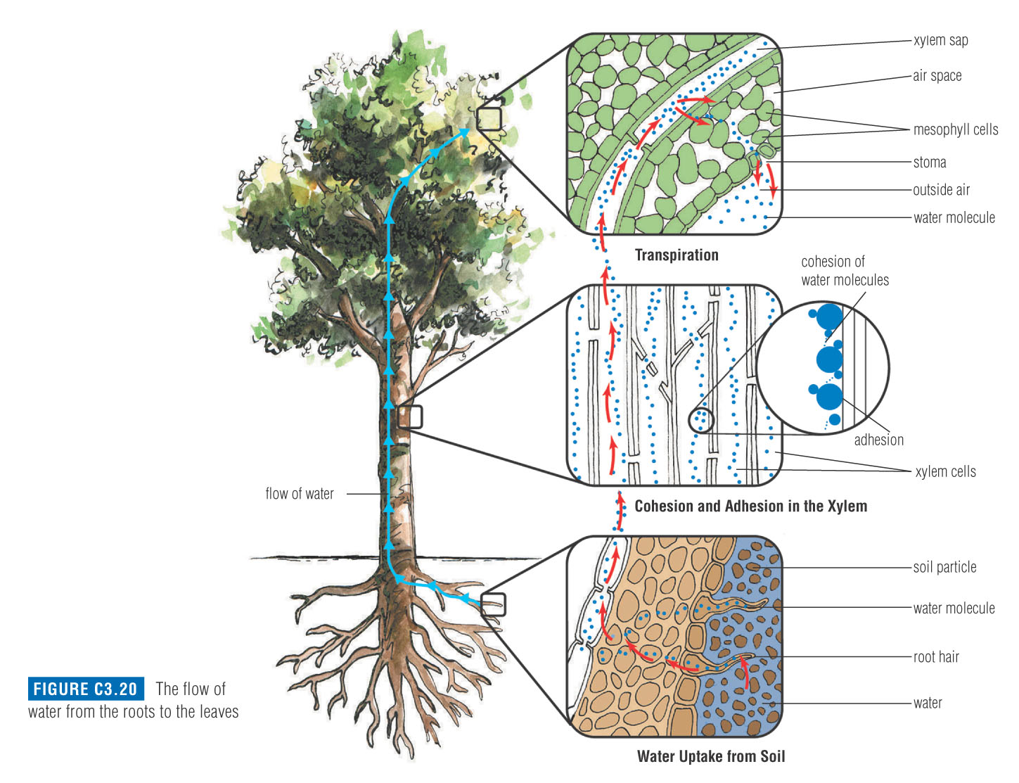
- At the Roots
Osmosis
- There is higher solute concentration and lower water concentration INSIDE of the roots than outside, therefore water enters the roots through
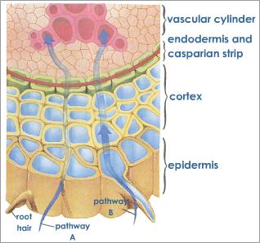
Root Pressure
- As water continues to move into the roots through osmosis there will be a buildup of water in the roots. There will be so much water that it will increase the pressure in the roots called . The pressure in the roots will help to push the water up. (Like a geyser)

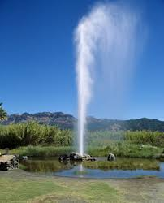

- In the Stem

- Cohesion= attraction of water molecules to other molecules
- Cohesion will cause the water molecules to stick together so when water is drawn up the molecules will all draw up together

- Adhesion= attraction of water molecules to
- Adhesion will cause the water molecules to stick to the sides of the stem and be drawn up the stem
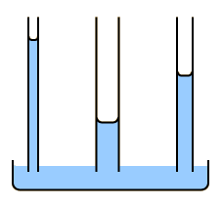

- At the Leaves

- Transpiration: the process of water vapor
- This process pulls water up the stem. (remember that all the water molecules are connected with cohesion so it is like pulling up a long chain)

- When Transpiration causes the water molecules to be pulled up the stem it is called

- Turgor Pressure: the guard cells will adjust to either open or close the stomata through turgor pressure.
- If the guard cells are full of water they are turgid and have a
- When the guard cells are they will be far apart therefore the stomata will be
- If the guard cells are low on water they are and have
- When the guard cells are limp they will be collapsed therefore the stomata will be

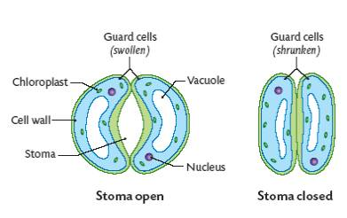

Phloem
- The mechanism of transport is a critical process for multicellular plants.
- It takes the products of photosynthesis from the place where they are produced, the leaves to places where they will be .
- In other words they are taken from a high concentration (a source) to a low concentration (a sink)
- At the leaf, the source of food, the phloem becomes loaded with sugar molecules from the sites of photosynthesis.
- Water then moves into the cells by osmosis.
- The water and sugar molecules then move into the sieve cells.
- The increased water pressure in the sieve cells pushes the water and sugars through the phloem to other parts of the plant.
- This movement of water and sugar is called the .

Plasmolysis:
When a plant cell is put into a HYPERTONIC solution, water will leave the through . This results in a ‘shrivelled up’ plant cell. This process is called .
When would a plant cell ‘be in’ a hypertonic solution?

Draw a picture of a plant cell with plasmolysis

Transport in Plants
- Grab a piece of poster paper.

- Draw a large plant with roots.

- Show and explain the movement of water up the plant, starting from the root and ending at the leaves.

- Label and explain how water moves from the roots to stem and up into the leaves. Use the following processes to explain this:
At the Roots
-osmosis
-root pressure

In the stem
-cohesion/adhesion

At the leaves
-include function of stomata
-include explanation of turgor pressure
-transpiration pull

- Identify why water needs to be used in the leaves. Use the following words/definitions to help you:
-photosynthesis
-chloroplasts

