Thermal ENERGY
Energy comes in two main categories:
- Kinetic Energy: the energy of
Examples:
- Potential Energy: The energy an object has because of its , rather than its motion
Examples: a

Energy comes in many forms of either kinetic or potential energy. Here are some examples:
- chemical energy: energy stored in the bonds of (atoms and molecules)
- electrical energy: energy made available by the flow of through a conductor
- nuclear energy: the energy stored in the and released during nuclear fission or fusion
- thermal energy: energy due to the

We are going to study THERMAL ENERGY more today.

Is thermal energy: POTENTIAL ENERGY or KINETIC ENERGY? (circle one)

Kinetic Molecular Theory of Heat
States
Solids: particles/molecules . This is the only motion experienced by this state of matter.
Liquids: particles/molecules also but they as well, giving them their familiar freedom to of whatever container they are poured in.
Gases Gas molecules move from one point to another; they're said to . Of course gas molecules still rotate and vibrate.

Hot vs. Cold
Heat= the transfer of from one object to another
Therefore cold is a lack of and hot is the abundance of

The Laws of Thermodynamics will help explain how thermal energy is transformed or transferred

1. Energy cannot be , but can be from one to another or from one to another.

2. No process can be . Some energy will always remain in the form of thermal energy.

Therefore, thermal energy always spontaneously flows from an object at a to an object at a .

Why is Batman correct?
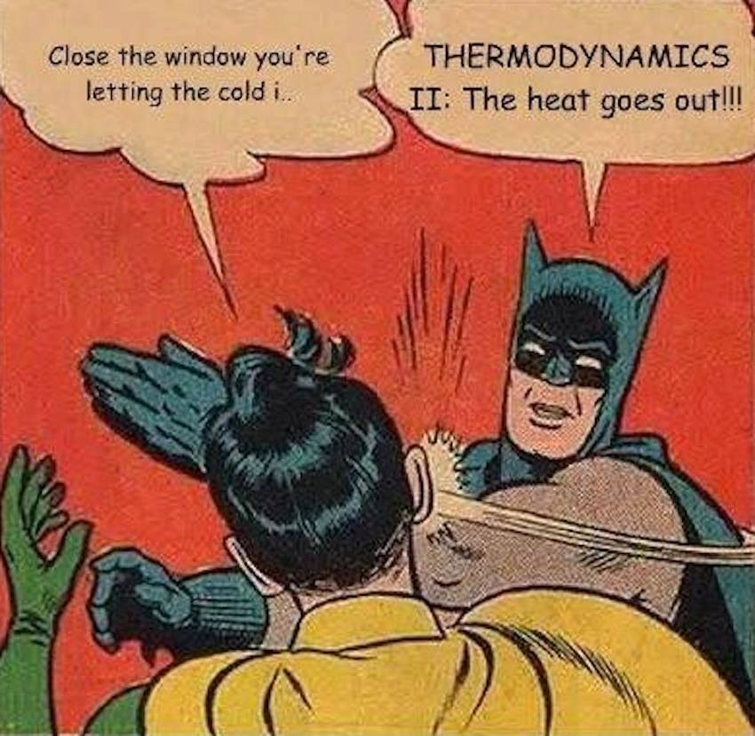

Using the definition of thermodynamics, thermal energy and particle movement explain the following scenarios:
- How a pot of soup can warm up on a stove

- An icecube melting in a hot bowl of soup can ‘cool off’ the soup

- An icepack on an injured knee

