Unit Analysis and Conversions
- It is quite often you will be required to convert one unit into another
- Unit analysis is a mathematical technique used to convert units

  - Multiply/divide to cancel out the unwanted units and into the wanted units

- Notice the information on the data sheet

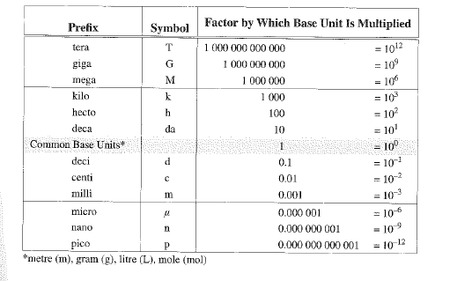

Examples
- Convert 5500 mm into m.

- Convert 83km into m.

- Convert 630mm into km.

- Convert 0.45kL into mL.

- Convert 20 km/h to m/s.

- Convert 720000 s into years.

